COLLEGE ERP SYSTEM

**Internal guide**

**Name :**karishma rao

**Designation:** professor

**Institute :** lokmanya collage of application (LCCA)

**External guide**

**Name:** yash soni

**Designation:** software trainer

**Institute:** prakshal IT academy

**Add:** 2’nd floor ,om avenue ,opp star bazar ,nr jodhpur cross road

Project profile:

Introduction of system:

ERP is stands for Enterprise Resource Planning. Enterprise resource planning (ERP) is business management software or a system which is typically used to manage core departmental data of respective business. ERP provides an integrated view of business processes, often in real-time, using common databases maintained by database management systems.

ERP system track business resources— raw materials, cash, production capacity and the status of business commitments like: payroll, purchase orders, and orders. The application that make up the system share data across the various departments (purchasing, accounting, sales, manufacturing etc.)That provides the core data. ERP facilitates information flow between business function, and manages connections to outside stakeholders.

Every college has to maintain a management system for various sections which may include performance analysis, attendance system, test wise result, student information, fee structure, academic information, transport facility.The erp college/university management module which is used by school as well as collages to manage their daily activity which include management of employees, students, assignment management , event management and other reports.

The COLLEGE ERP SYSTEM is a web-based social network system which is focused on make easy regular task between college student and their faculty. This system contains features of writing and posting a post or any event all at one place.

Languages and Development Tool

For the development of our system or website we use for frontend layout HTML, CSS, JAVA SCRIPTs languages and backend we have to used PHP we have used XAMPP server for create offline available working website.

Additional tool

To develop a diagrams, we have used Microsoft visio, XAMPP, notepad++, browser.

INTRODUCTION TOOLS

HTML

HTML stands for (hypertext markup language), it is developed by Tim Berners-Lee while at CERN, and popularized mosaic browser developed at NCSA during

1990s. HTML documents are written I plain text with special markup codes

Embedded right in the text. this means HTML file contains nothing but printable

Characters and HTML markup codes.

The markup codes that are types into a document enclosed with in these angle bracket < tags>. HTML can contain many tags for different uses.

<HTML>

<head>

<title >example of HTML document</title>

</head>

<body >

This is simple text documents

</body>

</HTML>

It is a platform independent language that can be work on any platform Linux,

Windows, iOS and so on. HTML code are not case sensitive. the browser does not display a HTML tags, but them to determine how to display the documents.

CSS

CSS stands for cascading style sheet it is used in HTML codes to enhance the

CSS describe how HTML elements are to display on screen, paper or other media. it can control the layout of multiple webpages all at ones.

The CSS specification are maintained by the world wide web alongside

HTML and JAVA SCRIPT .CSS codes are written in a curly bracket {}.

The CSS code can be written as below

H1{color: white;

Background: orange;

Border:1px solid black;

Padding: 0 0 0 0

Font-weight: bold;

}

JAVA SCRIPT

JAVA SCRIPT was invented by Brendan each in 1995 and become an ECMA standard in 1997. ECMA script is official name of the language.

JAVA SCRIPT is high level, interpreted programming language .it is also known as jess .JAVA SCRIPT can change HTML style(CSS). it is used in many desktop and server

Programs. node.js is the best example of this. some database like mongodb,and couchdb use JAVA SCRIPT as their program .

PHP

PHP stands PHP: hypertext preprocessor is a server side scripting language for web development and general purpose programming language. It was originally created by reassumes leadoff in 1994.PHP is a server scripting language, and powerful tool to making a dynamic and interactive web pages.

PHP code may be embedded into HTML code, or it can be used in combination of various web template systems .in our system PHP use in backend process.

A good benefit of using PHP is that it can be used in many different databases languages Including MySQL.

in database PHP can add add/delete or modified data.

it is powerful enough to be at the core of the biggest blogging website and deep enough to run the largest social network. PHP is compatible almost all

Servers used today (apache, IIS).

PHP file contain text, HTML, CSS, JAVA SCRIPT and PHP code the example of that given below.

<!doctype >

<html>

<head>

<title>PHP document</title>

</head>

<body>

<?PHP

Echo “this is a simple PHP documents …. ”

?>

</body></html>

SYSTEM REQUIREMENT

|  |  |
| --- | --- |
| Hardware | computer |
| Browser | Opera ,explorer and others |
| Software system | XAMPP server ,notepad++ ,browser |
| Database support | MySql database |
| Frontend | Html , JAVA SCRIPT ,CSS ,ajax, , j query |
| Backend | PHP |
| Supported hardware | Compute ,handheld device |

TRADITIONAL APPROACH ANALYSIS

Existing system :

* The main objective of the existing system is to provide a user-friendly interface. The COLLEGE ERP SYSTEM now computerizes all the task that are maintained manually. Once the details are fed into the system or computer there is no need for various persons to deal with separate sections. Only a person or admin is enough to maintain all the reports and database. The security can also be given as per the user requirements.
* in present this type of system is not made by any organization, which makes it more difficult.
* in real world institute, educational enterprise is yearly check their student’s project or assignment manually.

Collage erp system’s website provide:

* COLLEGE ERP SYSTEM is an online web based system which implements an user friendly and attractive interface for college. The aim for deployment and implementation of this system is to replace manual system of colleges with an automated web based system.
* In This system contain admin ,student and faculties all of them are
* Admin can add student and faculties so the system is very secure, any unauthorized user can’t be inheriting this system.
* User can not login in website without admin or faculty permission .
* In COLLEGE ERP SYSTEM faculties can add student without admin privileges.
* Build a strong communication between the student and the faculties.

Proposed system

* The following points are implements in proposed system:
* Students and faculties can login into system after once their registration is done by a admin.
* Once the student logged into system, he can write or ask question to officers regarding their subjects.
* Admin can view newsfeed posted by individual student.
* Admin login has full authority on system he can add /delete student or faculties.
* Admin can generate events and other important notification regarding their institute and university.
* Student can see answer about their question which is reply by officers or faculties.

PROBLEM IDENTIFICATION

Education system cannot check daily progress of student’s project.

Used to this system active internet connection is require to access this system.

User has to login after get admin credential ,faculty can not generate notification .

SOLUTION OF THESE PROBLEM

With using COLLEGE ERP SYSTEM Students can check their presence in college with Collage erp system end user can store database to store their data in system.

* The development of this system contains the following activities which try to automate the entire process keeping in the view of databases integration approach.
* User friendliness is provided in the application with various control provided by system rich interface.
* The system makes the overall project management much easier and flexible
* It can have accessed through internet.
* It is use smoothly on any low or old hardware component.
* Data are stored in server which is managed by admin.
* The user information can be store in centralized database which can be maintained by the system.
* The speed and accuracy of this system will improve more and more.

Feasibility study

A feasibility analysis usually involves a thorough assessment of the operational Financial and technical aspects of a proposal. Feasibility study is the test of the system proposal made to identify whether the user need may be satisfied using the current software and hardware technologies, whether the system will be cost effective or not from the business point of view and whether it can be developed with the given budgetary constraints. A feasibility study should be relatively cheap and done at the earliest possible time. depending on the study, the -decision is made whether to go ahead with a more detailed analysis.

When a new project goes through the feasibility assessments. Feasibility study is carried out to determine whether the proposed system is possible to develop with available resources and what should be the cost consideration. facts considered in the Feasibility analysis were

Operational feasibility

The computerized erp system will be faster than manual system.it is mainly related to human organization and enterprise service aspects. the points to be considered are.

* What changes will be brought with the application?
* What organizational structure are distributed?
* What new skills be required?
* does the existing project member have these skills? if not, can they be trained in course of time?
* the application is operationally feasible as it very fast for the end users to operate
* besides the new proposed system very much useful and there for it will be readily accepted by targeted users.

Technical Feasibility

# Technical feasibility deals with the hardware as well as software requirements. technology is not a constant to type an application development. it is a study of resource availability that may affect the ability to achieve an acceptable system. This evolution determines whether the technology needed for the proposed project is available or not.

The answer is yes. this system is independent to any operating system .it can be any type of hardware.

Can system can be upgraded or expanded if developed?

The answer is yes if we developed this system many more thing come in real life.

This is a concerned with specifying equipment and software that will successfully satisfy the user requirements.

Economic feasibility

* This feasibility study presents tangible and intangible benefit from the prefect by the comparing
* The development and operational cost. the technique of cost benefit analysis is often used as a basis
* For answering economic feasibility study. this system needs more initial investment then the existing system, but it can be justifiable that it will be improve quality of service.
* This feasibility study should contain following points …

workflows

admin module

Admin has all the access rights to the system. Admin is able to manage the student registration , Staff Registration, Academics, SMS gateway, . First he adds all the staff members of respective departments. Then the classes are added and the respective staff member is allocated to the class as a class coordinator.

After adding class and subjects the student admission process starts. This all tasks are managed by admin only.

This access is forbidden for the rest of users. Admin can manage the accounts of the all the students’ and staff a.

All the logs of student information can be view and manage by Admin itself. All the manual working of Admin is skipping through this system.

Workflow:

1. start
2. Login
   1. Add student
   2. Add faculties
   3. Generate circular
3. Logout
4. stop

Student module

Students are admitted by admin only to the system. When he got admitted the username and passwords are generated by admin and can be managed by student afterwards. Student has access to personal profile, all the notifications and upcoming events which are managed by admin.

Students also view his assignment given by faculty facility provided for students is to view the notification of his/her respective department

Student can also submit their assignment to the faculty .

1. Start
2. Login
   1. Get notification/events
   2. Ask question
   3. Submit assignment
3. Logout
4. Stop

**Faculty module**s

Staff or faculties are registered by admin and login details are generated by admin which can be managed by staff afterwards.

Staff has access rights to manage all the data of their subjects of respective class. They can manage assignment of students of respective subjects and classes.

Staff members are not able to give notifications .staff can upload some documents related to their respective subjects.

Instead of manual work this application gives automatic work.

Workflow:

1. Start
2. Login
   1. Show question and reply answer
   2. Get circular
   3. Add student
   4. Give assignment
3. Logout
4. stop

SYSTEM REQUIREMENTS SPECIFICATION(SRS)

System modules:

The system comprises of 3 major modules with their sub module as follows:

• Admin

• faculty

•student

1. Admin:
2. **Login:**

admin can login his personal account. with their login all admin credential and permission can be managed by admin.

1. **Add/delete student:**

admin add or delete student detail for registration into the system.

1. **Add/delete faculties:**

admin add or delete faculties detail for registration into the system.

1. **Generate notification/events:**

admin can generate notification and events regarding their institute.

1. **Show assignments:**

admin can show assignments of students.

1. **Show question:**

admin can show student’s post.

1. Faculty:
2. **Login:**

faculty can login after their registration into the system.

1. **Add/delete student:**

faculty can add/delete student into the entire system.

1. **Give answer:**

faculty can reply the student’s questions answer.

1. **Give assignment:**

faculty can give assignment to student.

1. **Show events:**

faculty can get notification which broadcast by admin.

1. **Update profile:**

after registration end user can change their profile data, which is managed by admin.

1. Student:
   1. **Login:**

faculty can login after their registration into the system.

* 1. **Ask question:**

student can ask question regarding their subjects.

* 1. **Submit assignment:**

student can submit their assignment to the faculty for any help.

* 1. **Show events:**

student can get events/notification broadcast by Admin.

* 1. **Update profile:**

like faculty, student can change their profile data after admin credential.

Design

A System Diagram (SD) in software engineering and systems engineering is a diagram that represents the actors outside a system that could interact with that system. This diagram is the high level view of a system, often software-based, as a whole and its inputs and outputs from/to external factors.

As System Diagrams,we are used data flow diagrams in our systems design to represent the more important external factors that interact with the system at hand.

The objective of a System Diagram is to focus attention on external factors and events that should be considered in developing a complete set of system requirements and constraints".

data flow diagram :

a data flow diagram is used to display how user can interact with system .

in.

**entity :**

|  |
| --- |
|  |

an entity be a real world object in the system which is used to show in our system.an entity set is a collection of similer types of entity.

**process:**

this symbol is used to display process. We can say as a subtask for any system.

**data flow :**

this is used to display data flow in any diagramme .

data flow has bidirectional flow which is defines as input and output.

Level 0 :









Level -2











a



















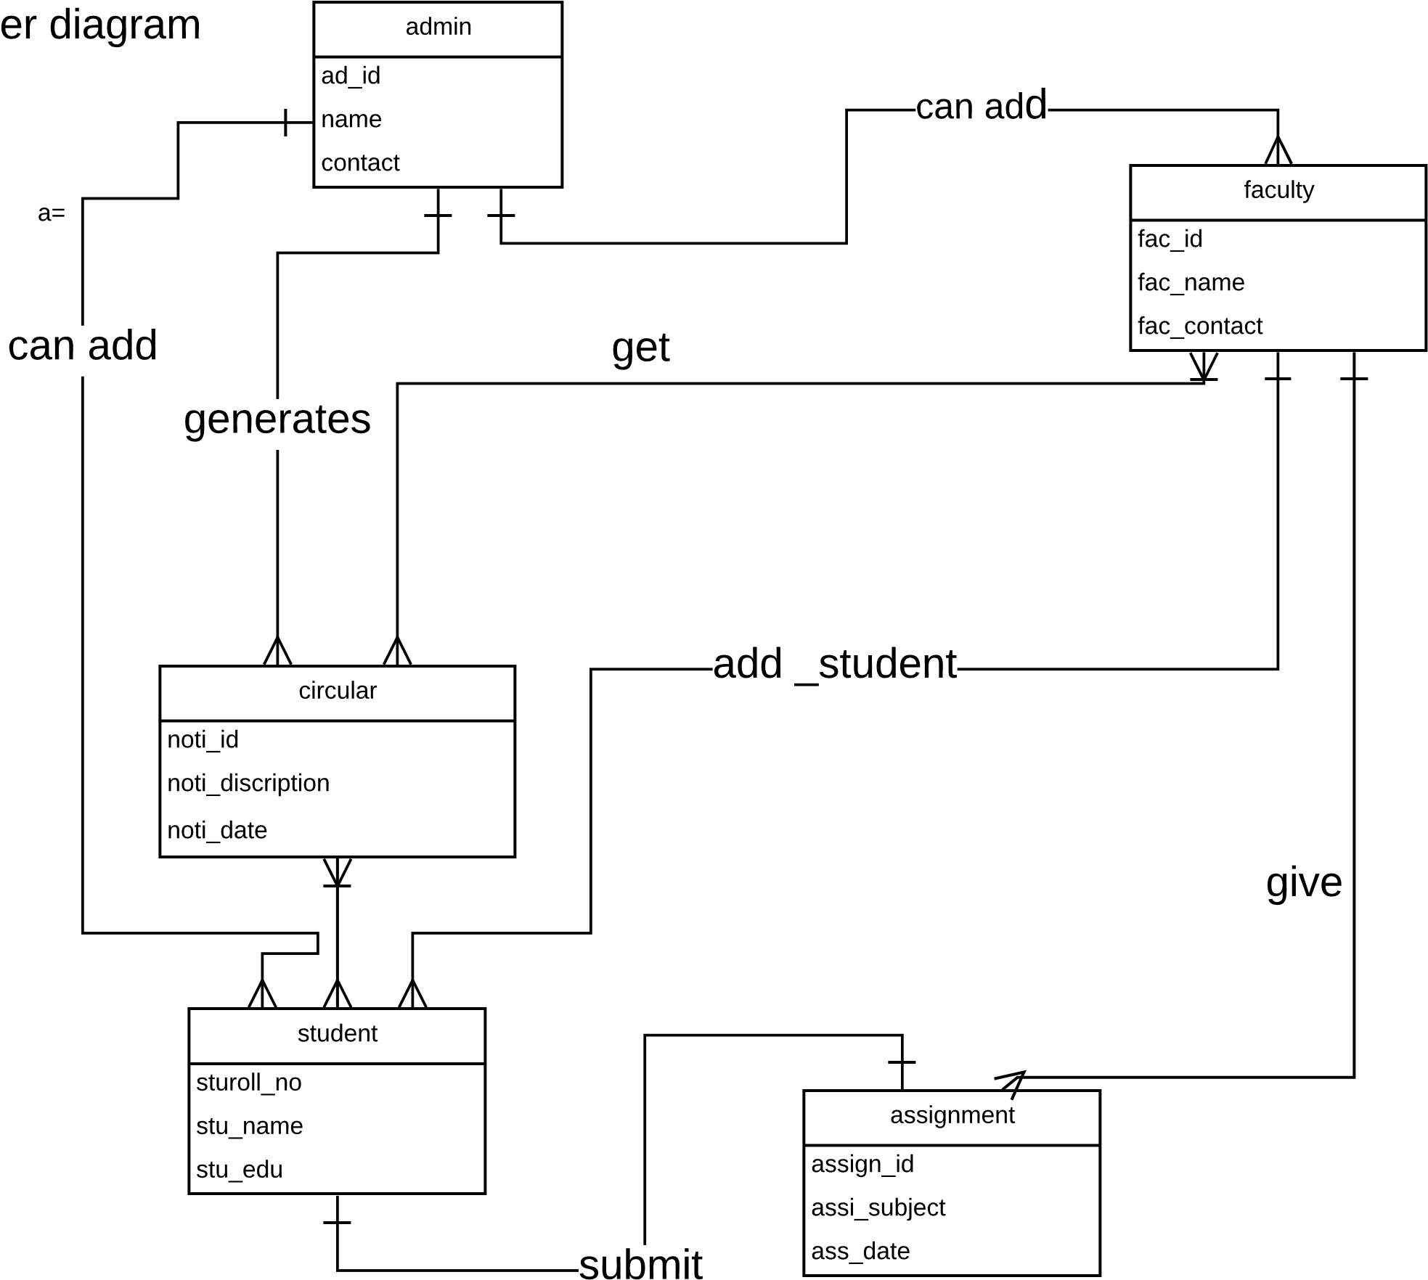



Date disctionary

|  |  |  |  |  |
| --- | --- | --- | --- | --- |
| table name | attribute name | type | constraints | description |
| cirq_tbl | noti_id | int(5) | primary key | ID OF notification |
| noti_title | varchar(50) | NOT NULL | Tittle OF NOTIFICATION |
| noti_description | varchar(100) | NOT NULL | description of NOTIFICATION |
| source | int(5) | FOREIGN KEY | source id |

|  |  |  |  |  |
| --- | --- | --- | --- | --- |
| table name | attribute name | type | constraints | description |
| questiondb | que_id | int(5) | primary key | ID OF QUESTION |
| que_tit | varchar(50) | NOT NULL | Tittle OF QUESTION |
| que_disc | varchar(50) | NOT NULL | description of question |
| source | int(5) | FOREIGN KEY | source id |
| dstn | int(5) | FOREIGN KEY | receiver id |
| que_flag | int(1) | NOT NULL | flag |

Assign_tbl :

in our database user’s assignment and material are stored in assignment table.

|  |  |  |  |  |
| --- | --- | --- | --- | --- |
| table name | attribute name | type | constraints | description |
| assign_tbl | ass_id | int(5) | primary key | ID OF ASSIGNMENT |
| ass_title | varchar(50) | NOT NULL | Tittle OF ASSIGNMENT |
| ass_disc | varchar(50) | NOT NULL | description of ASSIGNMENT |
| source | int(5) | FOREIGN KEY | source id |
| dstn | int(5) | FOREIGN KEY | reciever id |
| que_flag | int(1) | NOT NULL | flag |

|  |  |  |  |  |
| --- | --- | --- | --- | --- |
| table name | attribute name | type | constraints | description |
| register_tbl | user_id | int(5) | primary key | id of user |
| user_name | varchar(50) | Not null | name of user |
| password | varchar(50) | Not null | password |
| email id | varchar(30) | Not null | email id |
| proffesion | varchar(50) | Not null | profession or skills |
| category | varchar(50) | Not null | use d to enter user's criteria |

Home page:

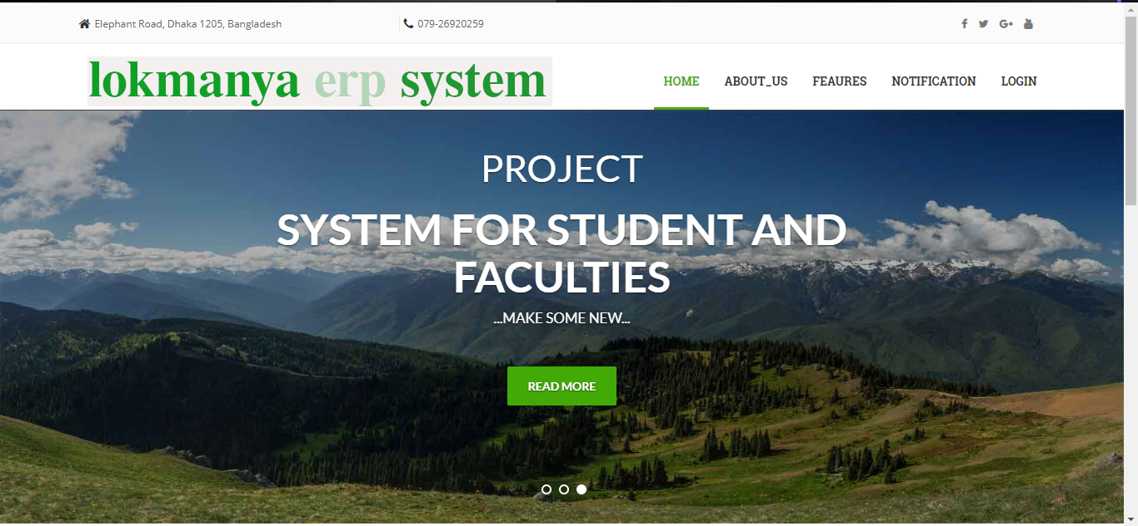

Homepage footer

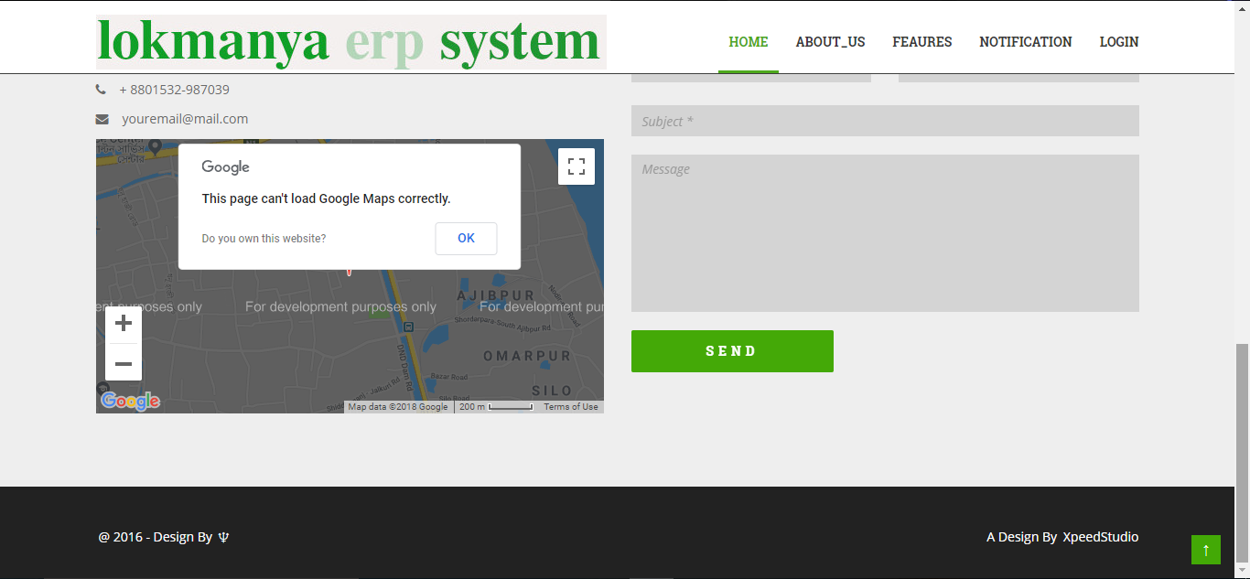

Future enhancement

if we developed this system we can add many more as well as simple things,

some examples are as given

* we will add event organizer for students in our system for create their own events and other information, which will be user can add them as personal or public.
* User can integrate mail_id to a erp system for better communications.
* Faculties can store daily report on this system like presence sheet ,
* If we developed this system ,we can add many more things like some notes, reminder,.
* We can develop our website more secure as possible and user friendly.
* We can update server and connect those to university’s result source page or website and indirect that data to the in our database.

Bibliography

The information given n this project documentation is borrowed from these following sites.

* [www.google.com](http://www.google.com)
* [www.wikipedia.com](http://www.wikipedia.com)
* [www.w3school.com](http://www.w3school.com)
* www.colorlib.com